**Task 3 – Creating a Class diagram and design pattern selection (30 marks)**

1. 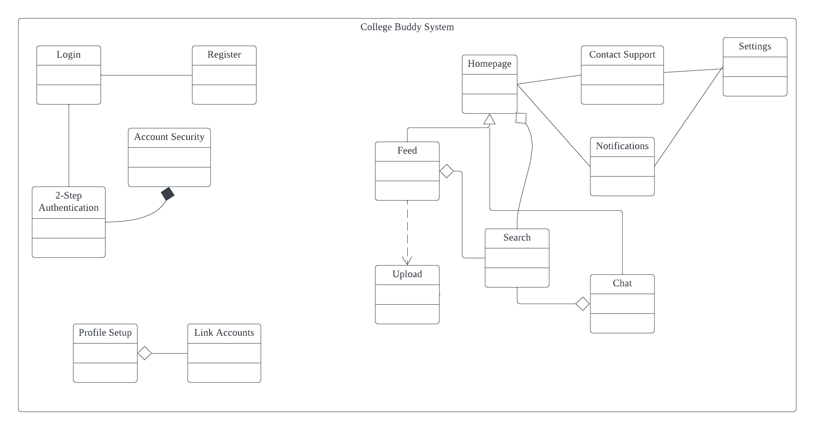Create a simple Class diagram which should consists of the Classes that might be used to represent the system and the association between them. You don’t have to declare the attributes and operations for this activity. You do have to explain the class responsibility of each class declared.

Class Responsibilities:

Login:

* Ensure the users has registered before gaining access to the app.
* To authenticate the user’s username and password and check if it matches with the one registered in the database.

Register:

* To collect information regarding the users and enable the users to create an account.
* To build a database for all the users of the college buddy system.

2-Step Verification:

* Prevents hacker from gaining access to the user’s account.
* To prevent user information being stolen or changed without the user’s consent.

Account Security:

* To protect every user’s account and personal information.
* Allow users to configure the strength of the security for the user’s account.

Profile Setup:

* To let the user’s setup their account properly for socializing.
* Allow the users to edit whenever the user felt that their account info needs to be updated.

Link Accounts:

* To share the user’s existing account from another online platform as a backup method to contact the user.
* To improve the user’s online presence in other platforms.

Homepage:

* The main hub of the college buddy system.
* To direct the users through all of the system’s features from the homepage itself.

Feed:

* To share activity from the users on the app.
* To provide users with some content to enjoy on the app.

Chat:

* Enable users to communicate with each other through text messages or voice calls and video calls.
* Grant users to create group chats which opens up for a larger scale of communication since the users are able to reach out to tons of users at once.

Upload:

* To allow users to share their thoughts and upload content of their own such as photos and videos.
* To contribute content for the feed page.

Search:

* Allow the users to find a certain user or a certain post on the app.
* To provide the users a great experience and assist them by providing the data the users requested.

Notifications:

* To alert the users of their buddies’ activities on the app.
* To alert the users of important notices or security breaches.

Settings:

* To grant the users to configure the features provided to them on the app to their liking.
* To allow users to change some functionalities and the app’s method of responding towards users.

Contact Support:

* Provide the users a method to contact official support agents when they are having trouble or require technical assistance.
* To enlighten the users if the users are having doubts on how to use a specific feature or if the users are looking for something very specific in the app.

1. Consider the problem and select a suitable design pattern that can be implemented on the problem. Give justification on why the design pattern was chosen. Draw the UML diagram representing your class diagram as a design pattern UML. Include all the abstract class/interface, concrete class and inheritance (if any) used to represent the problem.

One of the problems encountered was the notifications feature where the app will alert the user of any new activities from the user’s buddies without asking if the user want these notifications. Over the course of time, these notifications have become a nuance and forced a lot of users to turn off after these notifications have irritated them enough. In turn, a design pattern was needed to solve this issue and that is where the “Observer” design pattern comes into play. The “Observer” is a behavioural design pattern that allows the developers to define a feature which allows it to notify users of any activities that are occurring to the subject that the users are observing. In this case, the subject is the user’s buddies where the feature is the notification system. Once the user made a new buddy on the app, there will be an algorithm analysing what type of content made by the user’s buddy is most interacted by the user and there’ll be a pop-up windows that asks the user if they want to receive notifications from this certain buddy. If they accept it, the app will notify the user of the activity regarding the user’s selection and update the user’s feed with that said activity0; if they decline, they will not receive any notifications regarding the activity made by the buddy and the user’s feed will be sorted through the default settings which is the date of upload. The user can choose to reactivate the notifications from the buddy’s profile.

